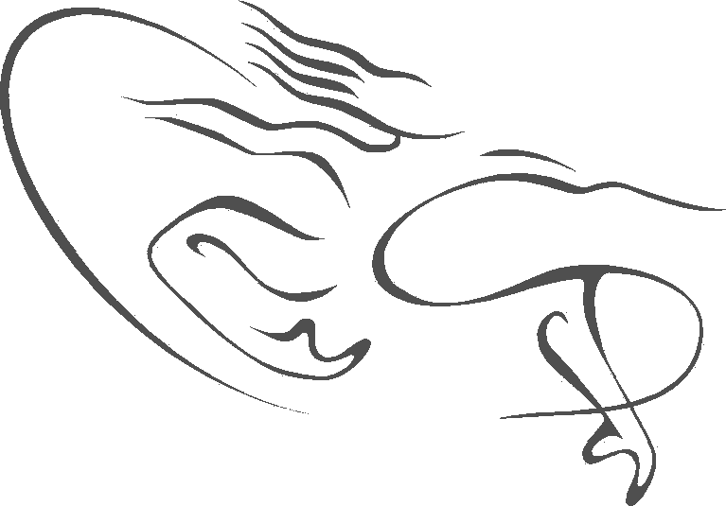
CAPE ACADEMY OF PERFORMING ARTS
2020 APPLICATION FORM:
FULL TIME PRE-PROFESSIONAL PROGRAM
Please complete this form neatly in capitals with black or blue pen or type.
- APPLICANT DETAILS
First Name

Middle Name(s)

Last Name

ID Number (Passport number for international citizens)

Date of Birth (day/month/year) | Age at 1st January 2019
Gender (please circle)  Male Female | Nationality
Postal address | Suburb and postcode (zipcode)
Province (State) | Country
Phone (home) | Phone (mobile)
Email

- PARENT / GUARDIAN DETAILS
Mother / Guardian

Phone (home) | Phone (mobile)
Email

Home address | Suburb and postcode (zipcode)
Province (State) | Country

Father / Guardian

Phone (home) | Phone (mobile)
Email

Home address | Suburb and postcode (zipcode)
Province (State) | Country

- AUDITION INFORMATION
Please select (circle) which stream you wish to audition for:

Classical Ballet, Contemporary Dance & Theatre related studies

Classical Ballet, Contemporary Dance & Theatre related studies with added focused classical dance

Please tick your category
South African resident
International citizen
Please tick your audition preference:
Saturday 17th August

Audition at Cape Academy of Performing Arts (Audition fee: R450.00)
2nd audition date to be confirmed

Audition at Cape Academy of Performing Arts (Audition fee: R450.00)
DVD audition* (Audition fee: USD50.00)

*Please note only applicants outside South Africa may audition via DVD
Private audition at Cape Academy of Performing Arts. This can only be arranged in extreme circumstances (Audition fee: R2500.00) Please contact CAPA to arrange date and time.

- ACADEMIC DETAILS
Highest certificate / qualification

School, College or University

Other education / academic certificates / qualifications

School, College or University

- DANCE TRAINING
Please provide full record of all dance training commencing with your most recent
Year(s) (e.g. 2012-2016) | Dance School
Styles (e.g.) ballet, jazz | Teacher(s)
Year(s) | Dance School
Styles | Teacher(s)
Year(s) | Dance School
Styles | Teachers(s)
If you require more space, please add additional sheets to the back of this application form

- DANCE TRAINING CONTINUED
Have you studied any of the following dance syllabi? If so, please state latest exam level, mark received and date and attach a copy of your most recent certification to this back of this application form
R.A.D. (Royal Academy of Dance)

CECCHETTI

ISTD (Imperial Society of Teachers of Dancing)

AIDT (Association of International Dance Teachers)

Other

- MEDICAL INFORMATION
Medical Aid Details (for South African residents only)
Medical Aid Scheme

Medical Aid Scheme Number

Do you have any allergies (e.g. to any medication, food or other)? If yes, please specify
Are you, or have you ever been a smoker? (Please circle) Yes No

Do you, or have you, suffered from any of the following (please circle):
Asthma | Yes No
Hepatitis | Yes No
Diabetes | Yes No
Scarlet Fever | Yes No
Any other diagnosed ailment(s)?

Have you ever had any stress fractures? If yes, please specify date and localisation (area)
Have you had any injuries in the last 5 years? If yes, what dance related or other injuries have you sustained and how were they treated?
Do you, or have you, suffered from any ailments of a psychological nature such as anxiety etc.? If so, please explain.
Do you take any medication, natural medicine (e.g. homeopathy, naturopathy) or supplements on a regular basis? If yes, please specify, including frequency of intake and reason for use

- FINANCE
Please provide details of person responsible for fees
Full Name
Relationship to applicant
ID Number (Passport number for international citizens) | *Please provide a certified copy of your ID with this application
Phone

- AUDITION FEE
The audition fee must be paid 7 days before your audition date and can be paid by Electronic Funds Transfer (EFT). Please contact CAPA for banking details.

Cape Academy of Performing Arts is unable to offer refunds unless the audition is cancelled by the School.
Audition fees
Audition at Cape Academy of Performing Arts | R450.00
Private audition at Cape Academy of Performing Arts | R2000.00
Video audition*  *Please note only applicants outside South Africa may audition via video | USD50.00
Total fee payable:

Audition fee payment deadline: 7 days before date of audition

Signature of applicant

Signature Date

Signature of person responsible for fees

Name (printed)

Signature Date

APPLICATION CHECKLIST*
1. | Completed application form
2. | Certified copy of ID of applicant (Passport if international student)
3. | Certified copy of ID of person responsible for fees
4. | Latest dance exam certificates (if applicable)
5. | Professional colour photographs with name written on reverse side of each photograph
6. | Evaluation report from two dance educators
7. | Essay of no more than 2 500 words on the following subject:  “Who I am, what inspires me to dance and what I can do for the Performing Arts”
8. | Physical assessment report from qualified dance/sports physiotherapist
9. | For international students: DVD (maximum duration 20 minutes)
10. | Audition fee paid to Cape Academy of Performing Arts via EFT (payment deadline: 7 days prior to audition date)

*Please see Audition Information Sheet for further details on additional documents required. The Audition Information Sheet can be found on the CAPA website: www.capa.co.za

Applicants are not only assessed on dance ability, but on their attitude and desire to pursue their craft, which should be evident in their essay submission.

Please post or courier full application to the following address:
AUDITIONS
Cape Academy of Performing Arts
Postnet Suite #303
Private Bag X16
Constantia, 7848
Western Cape
South Africa

